EXHIBIT "V"

EXHIBIT V-PAGE 1 OF 2

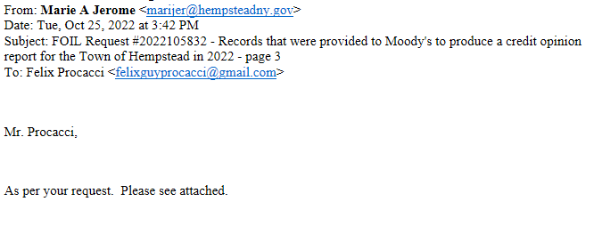
EXHIBIT V-PAGE 2 OF 2

